

Topic test 2
Name: __________________________________

Chapter 7: Loans and investments

- Time allowed: 45 minutes
- CAS calculators may be used.
- Part A: 5 multiple-choice questions (5 marks)
- Part B: 9 short-answer questions (27 marks)
- Part C: 3 analysis questions (18 marks)
Part A
Multiple-choice questions
5 multiple-choice questions
1 mark each: 5 marks
Circle the correct answer.
1 Sharon invests $14 000 at 5.8% p.a. simple interest, added weekly. How much will she have in 20 weeks?
A $312.31
B $14 315.64
C $14 312.31
D $16 240
E $315.64

[1 mark]
2 Sierra purchases an entertainment system worth $4500 on terms. She paid $1100 deposit and 11.8% p.a. flat rate interest on the balance. She pays the balance in equal fortnightly instalments over 1 year. The amount of each fortnightly instalment is:
A $146.20
B $193.50
C $173.08
D $130.77
E $147.11

[1 mark]
3 The difference equation tn+1 = tn × 1.086 where t1 = 37 000, represents an investment of:
A $37 000 at 1.086% p.a. compounded yearly
B $86 000 at 37% p.a. compounded yearly
C $37 000 at 10.86% p.a. compounded yearly
D $37 000 at 8.6% p.a. compounded yearly
E $1086 at 3.7% p.a. compounded yearly

[1 mark]
4 The following graph shows the increasing value of an investment over 10 years.
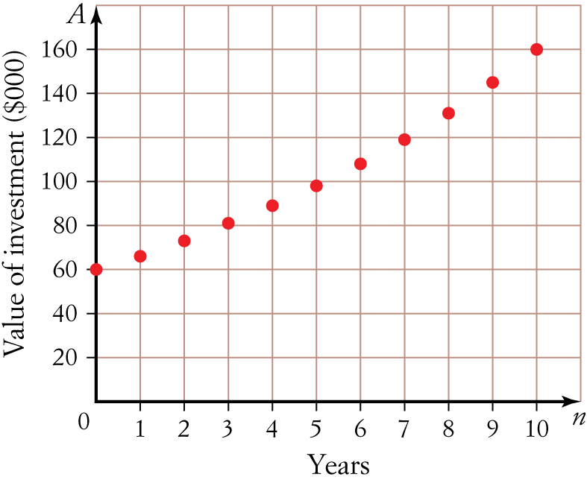

A rule for evaluating the value of the investment, in $, after n years could be:
A 60 × 0.103 × n
B 60 000 × (1.103)n
C 60 000 × 0.103 × n
D 60 × (1.103)n
E 60 000 × (0.103)n

[1 mark]
5 Neil and Jo each invest $27 000 at the following rates:
- Neil: 7.65% p.a. compounding quarterly
- Jo: 7.65% p.a. simple interest
At the end of 4 years, Neil will have:
A $1297.74 less than Jo
B $1297.74 more than Jo
C the same amount of money as Jo
D $997.34 less than Jo
E $997.34 more than Jo

[1 mark]
Part B
Short-answer questions
9 short-answer questions
27 marks
Show your working where appropriate.
1 Find the interest paid for a month if Arthur borrows $27 500 at 6.9% flat rate of interest.

[2 marks]
2 Renee wants to earn $5000 interest in 2 years. She invests in an account earning 11.2% p.a. simple interest. How much would she need to invest? Answer to the nearest one hundred dollars.

[3 marks]
3 Michael purchases office furniture valued at $4800 on terms of $480 deposit and 24 monthly instalments
of $224.04.
a How much interest does he pay in total?

b Calculate the annual flat rate of interest charged. Write your answer as a percentage correct to two
decimal places.

[4 marks]
4 $46 500 is invested at 6.3% p.a. compounded yearly.
a Using the formula tn = arn 1, find the rule for the geometric sequence.

b What will be the value of the investment after 8 years?

[3 marks]
5 Bradley invests $19 000 in an account paying 6.6% p.a. compounded quarterly.
a Write an expression involving the compound interest formula that can be used to find the value of his investment at the end of 5 years.

b Find the value of his investment at the end of 5 years.

[4 marks]
6 Narelle invests $16 400 in government bonds earning 7.15% p.a. compounding weekly. How much interest will she earn in 15 weeks?

[3 marks]
7 How long will $36 500 need to be invested at 7.8% p.a. compounded monthly in order to earn $7500 interest?

[3 marks]
8 Patrice invests her money in an account earning 7.9% p.a. compounded monthly. She sketches a graph showing the value of her investment over 7 years.
Which of the following could represent her investment? Justify your answer.
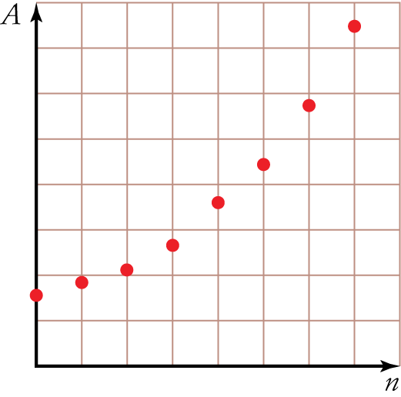
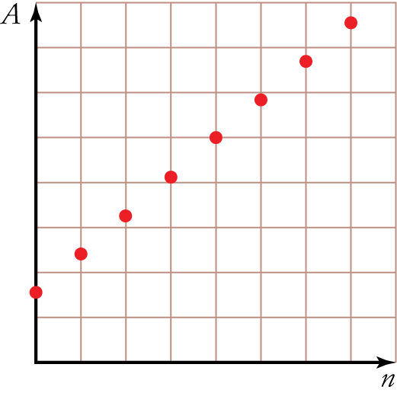
A B

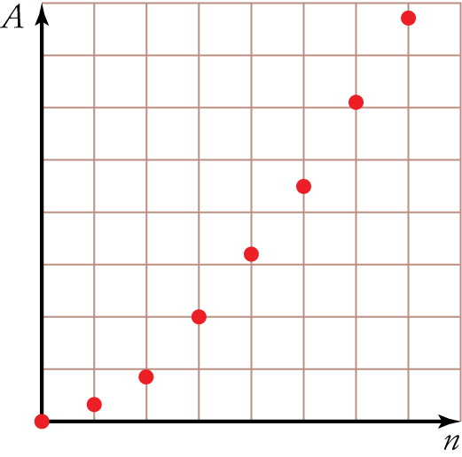
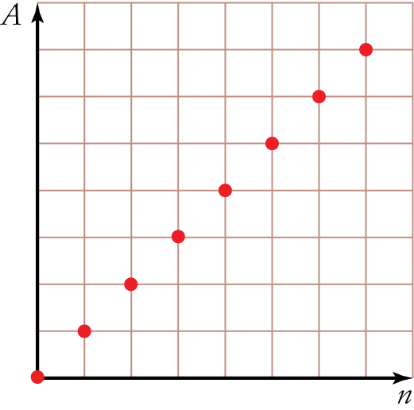
C D

[3 marks]
9 Calculate the effective interest rate for an investment earning 8.65% compounded 6-monthly. Answer as a percentage correct to one decimal place.

[2 marks]
Part C
Analysis questions
3 analysis questions
18 marks
Show your working where appropriate.
1 Melissa invests $4500 at 8.8% p.a. compounding 6-monthly. In working out the interest earned in the sixth year, she writes the following expression where she calculates the interest earned in 5 years and subtracts it from the interest earned in 6 years.
4500 × 1.0886  4500 × 1.0885
a Explain why this expression is incorrect.

b Write the correct expression.

c Hence, calculate the interest earned in the sixth year.

[3 marks]
2 Easy Saver and Super Saver are two investment options at a bank. They both pay interest yearly, but Easy Saver pays simple interest and Super Saver pays compound interest.
The graph below shows the amount to which each investment has grown over a 12-year period when $15 000 was initially invested in both.
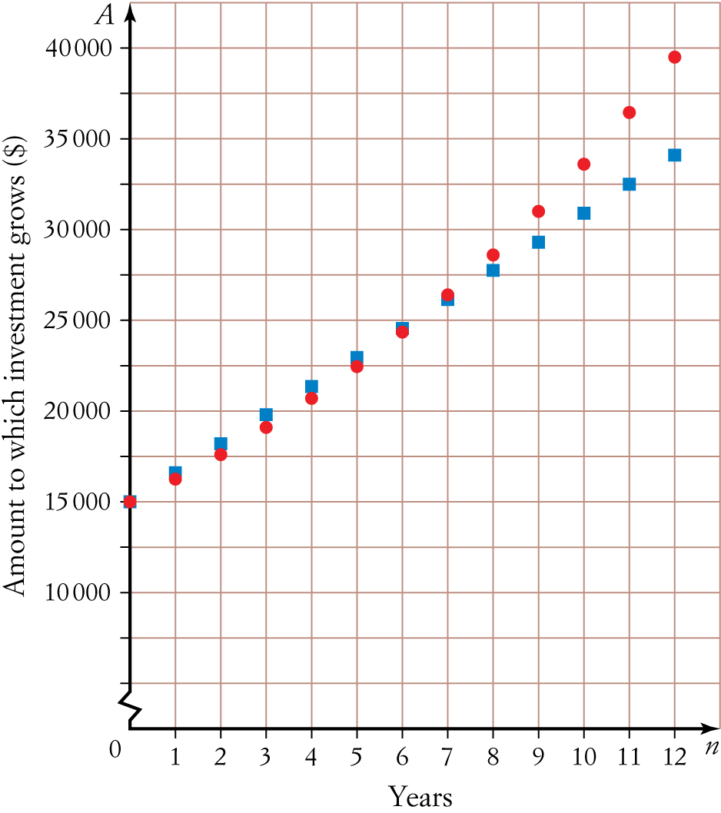

a How can you tell that the red-dotted line represents Super Saver?

b Which investment pays the lowest annual interest rate, Easy Saver or Super Saver? Justify your answer.

c After 12 years, the Easy Saver investment has grown to $34 100.
i Find the interest paid yearly.

ii Find the yearly interest rate for the Easy Saver investment. Answer as a percentage correct to one decimal place.

d After 12 years, the Super Saver investment has grown to $39 500. Find the yearly interest rate for the Super Saver investment. Answer as a percentage correct to one decimal place.

e If someone was deciding between Easy Saver and Super Saver, what advice would you give them? Explain.

[10 marks]
3 Alex was looking to invest money over 5 years. He is comparing different investment accounts:
- Account 1: 9.2% p.a. simple interest.
- Account 2: 9.2% p.a. compounded annually.
a The accounts have the same interest rate per annum but Account 1 earns less interest. Explain why.

Alex was also considering another account:
- Account 3: 9.1% p.a. compounded quarterly.
b Calculate the effective interest rates for Accounts 2 and 3.

c Which is the best option for him? Explain.

[5 marks]
[ Total marks: 50]
Answers
Part A – Multiple-choice questions [1 mark each]
1 I = ?, P = 14 000, r = 5.8, 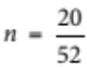
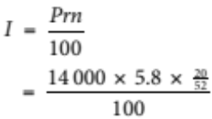
= 312.307…
≈ 312.31
 A = I + P
= 312.31 + 14 000
= 14 312.31
 C
2 Balance = 4500  1100
= 3400
 I = ?, P = 3400, r = 11.8, n = 1
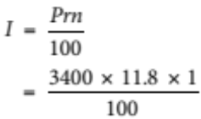
= 401.20
 Total to repay = 401.20 + 3400
= 3801.20
 Fortnightly instalment = 3801.20  26
= 146.20
 A
3 t1 = initial value
= the principal
= 37 000
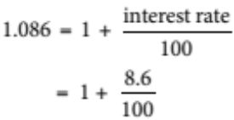
 Interest rate = 8.6% p.a.
 D
4 Graph is curved, so we are using compound interest.
Therefore, it will take the form:
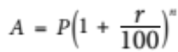  not options A or C.
Reading from the graph, the initial starting value (i.e. the principal) is $60 000.
 not option D.
Value in parentheses must be 1 ∴ not option E.
 B
5 Neil:
N = 4 × 4 = 16
I(%) = 7.65
PV = 27 000
Pmt = 0  FV = 36 559.735…
FV = ? ≈ 36 559.74
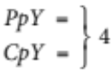
PmtAt = END
Jo:
I = ?, P = 27 000, r = 7.65, n = 4
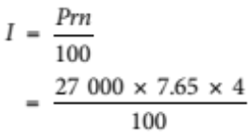
= 8262
 A = I + P
= 8262 + 27 000
= 35 262
 Difference = 36 559.74  35 262
= 1297.74
 Neil will have $1297.74 more than Jo.
 B
Part B – Short-answer questions
1 I = ?, P = 27 500, r = 6.9, 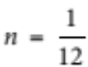 [1 mark]
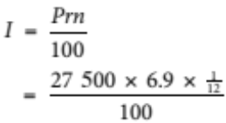
= 158.125
 158.13 [1 mark]
 $158.13 interest paid for a week.
2 I = 5000, P = ?, r = 11.2, n = 2 [1 mark]
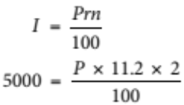 [1 mark]
 P = 22 321.428…
 22 300 [1 mark]
 She needs to invest $22 300.
3 a Total paid = 224.04 × 24 + 480
= 5856.96 [1 mark]
 Interest = 5856.96  4800
= 1056.96 [1 mark]
Therefore, he paid $1056.96 interest.
b Amount borrowed = 4800  480
= 4320 [1 mark]
 I = 1056.96, P = 4320, r = ?, n = 2
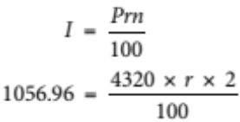
 r = 12.233…%
= 5.87%
Therefore, the flat rate of interest charged is 12.23% p.a. [1 mark]
4 a a = principal
= 46 500
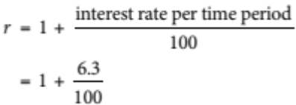
= 1.063
 tn = arn1
= 46 500 × 1.063n1 [1 mark]
b After 8 years, n = 9 [1 mark]
 tn = 46 500 × 1.0639 1
= 75 808.703…
 75 808.70
 The value of the investment after 8 years will be $75 808.70. [1 mark]
5 a A = ?, P = 19 000, r = 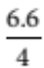 = 1.65% per quarter, n = 5 × 4 = 20 quarters
[1 mark for r and 1 mark for n]
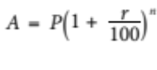
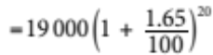 [1 mark]
Should also accept 19 000 × 1.016520
b A = 26 357.320…
 $26 357.32
His investment will be worth $26 357.32 at the end of 5 years. [1 mark]
6 N = 15 [1 mark for writing known values either in list or in formula.]
I(%) = 7.15
PV =  16 400
Pmt = 0  FV = 16 741.525…
FV = ?  16 741.53 [1 mark for FV ]
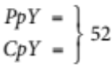  I = 16 741.53  16 400
PmtAt = END = 341.53
Therefore, she will earn $341.53 interest in 15 weeks. [1 mark]
7 N = ? [1 mark for writing known values either in list or in formula.]
I(%) = 7.8
PV = 36 500
Pmt = 0  N = 28.8… months [1 mark]
FV = 44 000  29 months
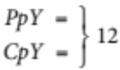
PmtAt = END
Therefore, it will take 2 years and 5 months. [1 mark for N ]
8 Graph A [1 mark]
It is compound interest, so it must be a curved line graph  A or C.
[1 mark for this reason]
We want the value of her investment, so, at n = 0, the value is the principal. Therefore, the graph must start above the zero on the y-axis  A.
[1 mark for this reason]
9 I = 8.65% = 0.0865, n = 2
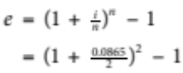 [1 mark]
= 0.0883…
 8.8% [1 mark]
Therefore, the effective interest rate is 8.8%.
Part C – Analysis questions
1 a It has the interest rate and years as compounding yearly, but it should be compounding 6-monthly. [1 mark]
b 4500 × 1.04412  4500 × 1.04410 [1 mark]
c 622.516…  622.52
Therefore, the interest earned in the sixth year is $622.52. [1 mark]
2 a It is a curved line which represents a compound interest investment. [1 mark]
b Super Saver [1 mark]
Initially, Super Saver earns the least interest. This can be seen by the fact that the line marked with dots is initially below the line marked with squares. [1 mark]
c i Total interest = 34 100  15 000
= 19 100 [1 mark]
 Interest per year = 19 100  12
= 1591.666…
 1591.67
 Interest paid per year is $1591.67. [1 mark]
ii I = 1591.67, P = 15 000, r = ?, n = 1 [1 mark for using correct I and P ]
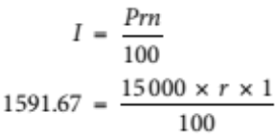
∴ r = 10.61…% p.a.
 10.6% p.a. [1 mark]
d N = 12 [1 mark for writing known values either in list or in formula.]
I(%) = ?
PV = 15 000
Pmt = 0  r = 8.40…
FV = 39 500  8.4% p.a.
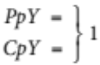
PmtAt = END
Therefore, the interest rate for the Super Saver investment is 8.4% p.a. [1 mark]
e If investing for more than 6 years, the Super Saver account is the best option. Otherwise, Easy Saver is the best option. This can be seen on the graph as below 7 years the Easy Saver graph is above the Super Saver but from 7 years it is reversed. [1 mark]
3 a Account 1 earns simple interest, which means interest is earned on the principal only. The interest
earned in Account 2 is compounded, which means the interest earned each year gets added to the principal.
Thus, interest is earned on the previous year’s interest as well as on the principal. [1 mark]
b Account 2: e = 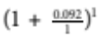  1 = 0.092…
 9.2% [1 mark]
Account 3: e = 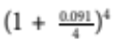  1 = 0.09415…
 9.41% [1 mark]
c Account 3 is the best option. [1 mark]
It has the higher effective interest rate and will therefore pay higher interest over time. [1 mark]

